**Ethical issues relating to programming forum system for college students**

As the usage of technology in modern society continues to grow exponentially, scientists are consistently coming up with new ideas and implementations to improve technology. However, as with all advancements in life, when there are pros, there are also cons. With technology advancing at such a fast rate, more vulnerabilities and issues are being exposed to the public. Among them are the topics regarding ethics, where discussions are made on whether certain features or applications should be implemented due to moral concerns. Ethics regarding the development of a programming forum system for college students will be discussed further, and a critical analysis will be made based on a similar forum system, “StackOverflow”.

1. Privacy Concerns

Our data is being uploaded to the Internet in large amounts every day. Illegal access by other users is considered as infringement of privacy. In Malaysia, the only law that ensures our data’s safety is the Personal Data Protection Act 2010 (PDPA). Hence, to prevent hacking by unauthorized users, a two-factor authentication method should be used to verify the student’s identity before allowing access into the forum. This ensures that no one can impersonate the student as well as prevent the hacker from accessing the student’s account. Upon registering an account, students should also be notified that their data is only being collected for the forum’s purposes. They should also have the option to enable or disable cookies as well if they do not wish to be tracked by third parties.

A notable issue regarding privacy invasion is Facebook’s tracking of StackOverflow’s user activity in 2019 (Amrata J., 2019). Facebook had obtained user data from StackOverflow through their third-party cookies, resulting in Facebook obtaining useful data such as user interests to improve their own targeting services. Through these data mining techniques, users are concerned for their online safety. It also raises the questions: Will Facebook’s unethical actions cause users to leave the platform entirely? To what extent is data collection considered acceptable?

Another privacy issue to be discussed is anonymity. Anonymity is like a double-edged sword, on one hand, it allows users to share their ideas in the forum without fear of being discriminated, but on the other hand, there are users who exploit this function for their own personal gain. Anonymous users might intentionally hide their identity with the intent to create spam, or cause problems in the forum. To combat this issue, we can implement a feature to restrict activities of those users. StackOverflow achieves this by creating “protected questions”, where only users with a certain level of reputation can share their answers (StackOverflow, 2021). It is an efficient way to the reduce workload of moderators by automatically disabling the answer function for anonymous users. That way, there will be reduced spam in the programming forum, such as duplicate questions or meaningless answers.

1. Intellectual Property Rights

Furthermore, there are concerns revolving around intellectual property rights. Every post or code snippet on StackOverflow is copyrighted under the Creative Commons License. In the programming forum, each author should be entitled to ownership of their work and users should give credit to the original authors whenever necessary.

Plagiarism in the programming community has grown rampant over the years, especially when there are open discussion forums like these where ownership is often overlooked. It is also hard to determine whether a particular snippet of code is copied or not because some functions have little to no variation in syntax. However, users need to be aware that it is unethical to replicate someone else’s work without giving proper citation. Plagiarism can also lead to bigger problems, such as insecure code. According to the 2017 IEEE Symposium on Security and Privacy, out of 1.3 million Android applications analysed, 15.4% of them contained code that were obtained from StackOverflow, 97.9% had at least one insecure code snippet (F. Fischer et al., 2017). Such vulnerabilities in code lead to high risk of data leaks and privacy invasions. Bad habits form easily, so if students begin to copy code directly from the programming forum in their college years, they might do so when they enter the workforce as well. Students may also become dependent on the programming forum. Therefore, there is a risk where they do not attempt to solve problems by themselves first but instead search for the answer straightaway. This results in less creativity and thus the programmer cannot improve their skills.

1. Effects on society

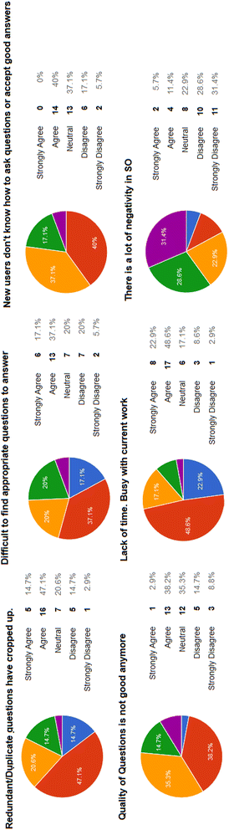In a programming forum, there are bound to be heated discussions. However, there are mixed reviews on the inclusivity of such forums (Jay H., 2018). Taking StackOverflow as an example, new users are often judged for asking “easy or duplicate questions”, while experienced users act condescendingly towards them. A study that was conducted to investigate the behaviours of users at StackOverflow had revealed that users were more likely to answer questions if they had the same nationality as well (Ahmed, T., Srivastava, A., 2017). Such conflicts have led to users slowly reducing their activity on the forum. A survey was conducted to understand the reason behind their departure, and it is shown as follows (Ahmed, T., Srivastava, A., 2017).:

Figure 1: Reasons for decreased participation

From the chart, we see that the respondents generally agree that new users have trouble asking questions properly and the quality of questions is dropping. Question redundancy is also agreed upon. Hence, a toxic community should be prevented by enforcing strict forum guidelines and hiring moderators to ensure that the atmosphere in the forum is friendly. Only then, users will be engaged actively to help each other out, resulting in a positive feedback loop.

In conclusion, ethics is a grey area where no one is completely right or wrong. However, we should, as a community, do our best and be responsible for our actions when using software to minimize damages.

References:

Ahmed, T., Srivastava, A. (2017) “Understanding and evaluating the behavior of technical users. A study of developer interaction at StackOverflow.” *Human-centric Comuting and Information Sciences*. 7(8) [Online]. Available at: <https://hcis-journal.springeropen.com/track/pdf/10.1186/s13673-017-0091-8.pdf> [Accessed: 27 October 2021].

Amrata J. (2019) *Facebook again, caught tracking Stack Overflow user activity and data* [Online]. Available at: <https://hub.packtpub.com/facebook-again-caught-tracking-stack-overflow-user-activity-and-data/> [Accessed: 27 October 2021].

F. Fischer et al. (2017) "Stack Overflow Considered Harmful? The Impact of Copy & Paste on Android Application Security," *2017 IEEE Symposium on Security and Privacy (SP)*, pp. 121-136 Available at: <https://ieeexplore.ieee.org/stamp/stamp.jsp?tp=&arnumber=7958574> [Accessed: 27 October 2021].

Jay H. (2018) *Stack Overflow Isn’t Very Welcoming. It’s Time for That to Change.* [Online]. Available at: <https://stackoverflow.blog/2018/04/26/stack-overflow-isnt-very-welcoming-its-time-for-that-to-change/?_ga=2.168735201.1912423055.1634911547-550606994.1629707138> [Accessed: 27 October 2021].

StackOverflow (2021) *Protected questions.* StackOverflow. [Online]. Available at: <https://stackoverflow.com/help/privileges/protect-questions> [Accessed: 27 October 2021].